IT24104175 lab sheet 05 Nitharshana G

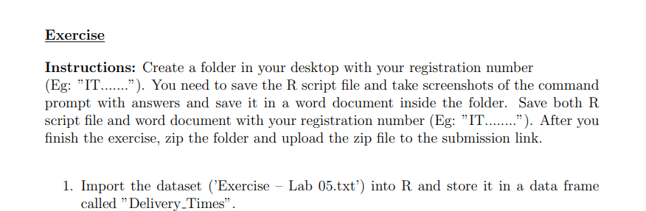

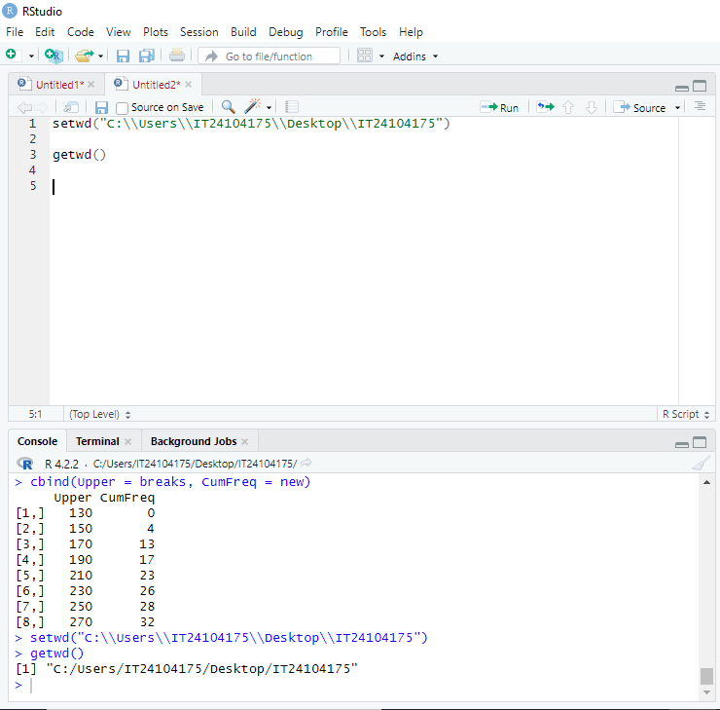



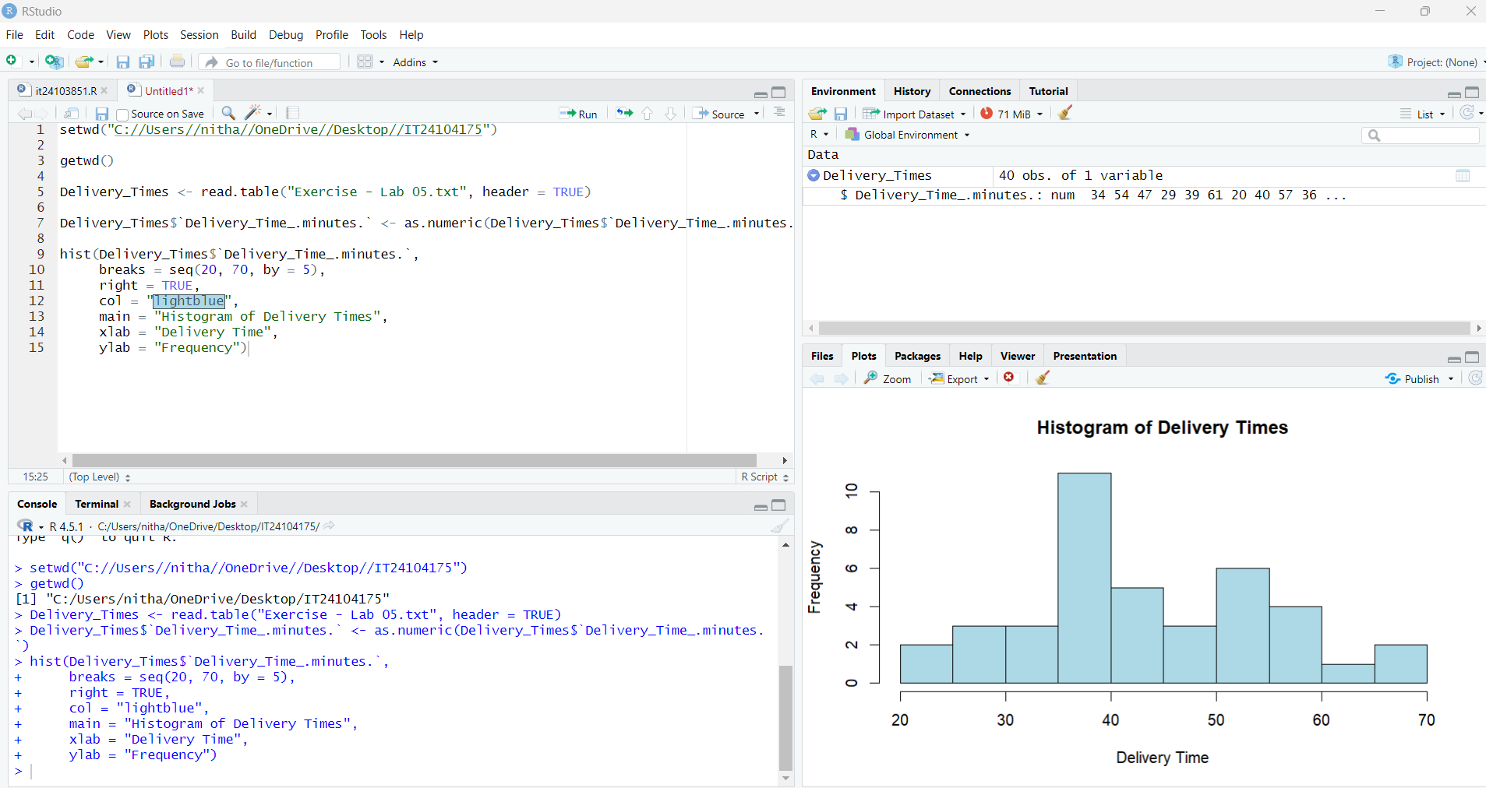

3. Comment on the shape of the distribution.

• The histogram shows most delivery times are concentrated between **35 and 45 minutes**, with the highest frequency around **38–40 minutes.**

• The distribution is **approximately unimodal** (one clear peak).

• It appears to be **slightly right-skewed** (a longer tail on the higher delivery times side), as there are fewer observations above 55–70.

• There are no extreme outliers visible; the spread looks moderate.

4. Draw a cumulative frequency polygon (ogive) for the data in a separate plot.

